PROGRAM 1

Q1. Write a program to sort the elements of an array in descending order.
import java.util.Scanner;
public class DescendingSort {
public static void main(String[] args) {
Scanner sc = new Scanner(System.in);
System.out.println("Name: Venayak Saxena");
System.out.println("Q1. Program to Sort Array in Descending Order");
System.out.println("---------------------------------------------");
System.out.print("Enter number of elements: ");
int n = sc.nextInt();
int arr[] = new int[n];
System.out.println("Enter elements:");
for(int i = 0; i < n; i++) {
arr[i] = sc.nextInt();
}
for(int i = 0; i < n - 1; i++) {
for(int j = 0; j < n - i - 1; j++) {
if(arr[j] < arr[j + 1]) { // Descending condition
int temp = arr[j];
arr[j] = arr[j + 1];
arr[j + 1] = temp;
}
}
}
System.out.println("Array in Descending Order:");
for(int i = 0; i < n; i++) {
System.out.print(arr[i] + " ");
}
sc.close();
}
}


OUTPUT 1:
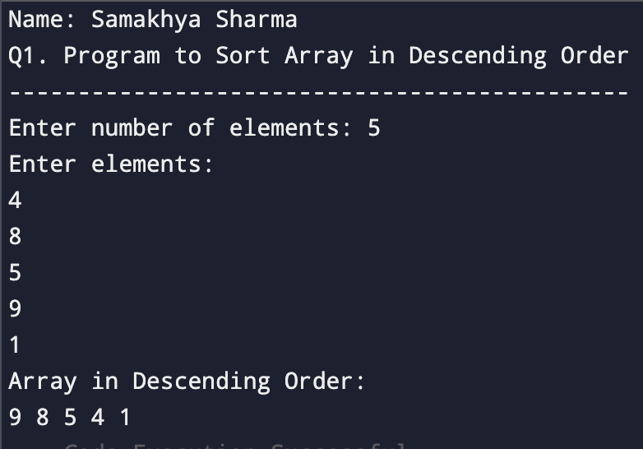

PROGRAM 2
Q2. WAP to maintain student academic records and display complete details.

import java.util.Scanner;
public class Student {
int rollNo;
String name;
String course;
int semester;
float marks1, marks2, marks3;
float total, percentage;
void inputDetails() {
Scanner sc = new Scanner(System.in);
System.out.print("Enter Roll Number: ");
rollNo = sc.nextInt();
sc.nextLine();
System.out.print("Enter Student Name: ");
name = sc.nextLine();
System.out.print("Enter Course Name: ");
course = sc.nextLine();
System.out.print("Enter Semester: ");
semester = sc.nextInt();
System.out.print("Enter Marks of Subject 1: ");
marks1 = sc.nextFloat();
System.out.print("Enter Marks of Subject 2: ");
marks2 = sc.nextFloat();
System.out.print("Enter Marks of Subject 3: ");
marks3 = sc.nextFloat();
total = marks1 + marks2 + marks3;
percentage = total / 3; }
void displayDetails() {
System.out.println("\n--- Student Academic Record ---");
System.out.println("Roll Number : " + rollNo);
System.out.println("Name : " + name);
System.out.println("Course : " + course);
System.out.println("Semester : " + semester);
System.out.println("Total Marks : " + total);
System.out.println("Percentage : " + percentage + "%"); }
public static void main(String[] args) {
System.out.println("Name: Venayak Saxena");
System.out.println("Q2. Student Academic Report");
System.out.println("-----------------------------------");
Student s = new Student();
s.inputDetails();
s.displayDetails();}}
OUTPUT 2:

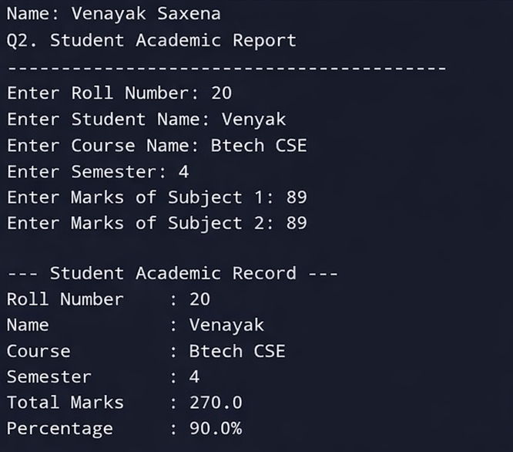
PROGRAM 3
Q3. Write a java program to model an organization having different categories of employees whose salary is computed differently.

import java.util.Scanner;
public class Employee {
int empId;
String name;
double salary;
void inputDetails() {
Scanner sc = new Scanner(System.in);
System.out.print("Enter Employee ID: ");
empId = sc.nextInt();
sc.nextLine();
System.out.print("Enter Employee Name: ");
name = sc.nextLine();
}
void calculateSalary() {
}
void displayDetails() {
System.out.println("\nEmployee ID : " + empId);
System.out.println("Employee Name : " + name);
System.out.println("Salary : " + salary);
}
public static void main(String[] args) {
System.out.println("Name: Venayak Saxena");
System.out.println("Q3. Categories of Employees");
System.out.println("-----------------------------------");
Scanner sc = new Scanner(System.in);
System.out.println("1. Full Time Employee");
System.out.println("2. Part Time Employee");
System.out.print("Choose Employee Type: ");
int choice = sc.nextInt();
Employee emp;
if (choice == 1) {
emp = new FullTimeEmployee();
} else {
emp = new PartTimeEmployee();
}
emp.inputDetails();
emp.calculateSalary();
emp.displayDetails();
}
}
class FullTimeEmployee extends Employee {

double basic, hra, da;

void calculateSalary() {
Scanner sc = new Scanner(System.in);
System.out.print("Enter Basic Salary: ");
basic = sc.nextDouble();
hra = 0.20 * basic;
da = 0.10 * basic;
salary = basic + hra + da;
}
}
class PartTimeEmployee extends Employee {
int hoursWorked;
double ratePerHour;
void calculateSalary() {
Scanner sc = new Scanner(System.in);
System.out.print("Enter Hours Worked: ");
hoursWorked = sc.nextInt();
System.out.print("Enter Rate per Hour: ");
ratePerHour = sc.nextDouble();
salary = hoursWorked * ratePerHour;
}
}

OUTPUT 3:

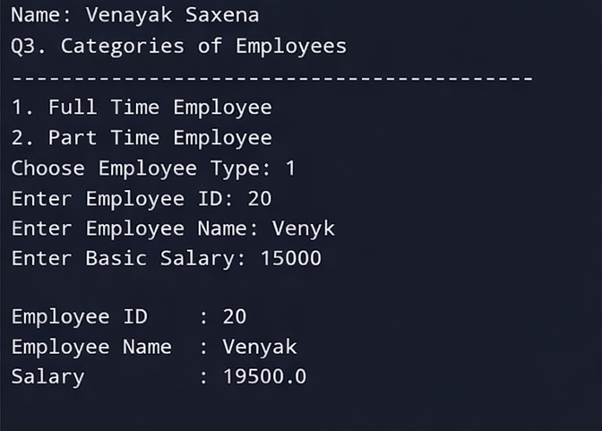
PROGRAM 4
Q4. Develop a Java program to implement a digital payment system supporting multiple payment modes with different processing logic.

import java.util.Scanner;
public abstract class Payment {
double amount;
abstract void processPayment();
void inputAmount() {
Scanner sc = new Scanner(System.in);
System.out.print("Enter Payment Amount: ");
amount = sc.nextDouble();
}
public static void main(String[] args) {
System.out.println("Name: Venayak Saxena");
System.out.println("Q4. Digital Payment System");
System.out.println("-----------------------------------");
Scanner sc = new Scanner(System.in);
System.out.println("1. Credit Card Payment");
System.out.println("2. UPI Payment");
System.out.println("3. Cash Payment");
System.out.print("Select Payment Mode: ");
int choice = sc.nextInt();
Payment payment;
switch (choice) {
case 1:
payment = new CreditCardPayment();
break;
case 2:
payment = new UPIPayment();
break;
case 3:
payment = new CashPayment();
break;
default:
System.out.println("Invalid Choice");
return;
}
payment.inputAmount();
payment.processPayment();
}
}
class CreditCardPayment extends Payment {
void processPayment() {
System.out.println("Processing Credit Card Payment...");

System.out.println("Payment of Rs. " + amount + " completed using Credit Card.");
}
}
class UPIPayment extends Payment {
void processPayment() {
System.out.println("Processing UPI Payment...");
System.out.println("Payment of Rs. " + amount + " complet using UPI.");
}
}
class CashPayment extends Payment {
void processPayment() {
System.out.println("Processing Cash Payment...");
System.out.println("Payment of Rs. " + amount + " received in cash.");
}
}
OUTPUT 4:

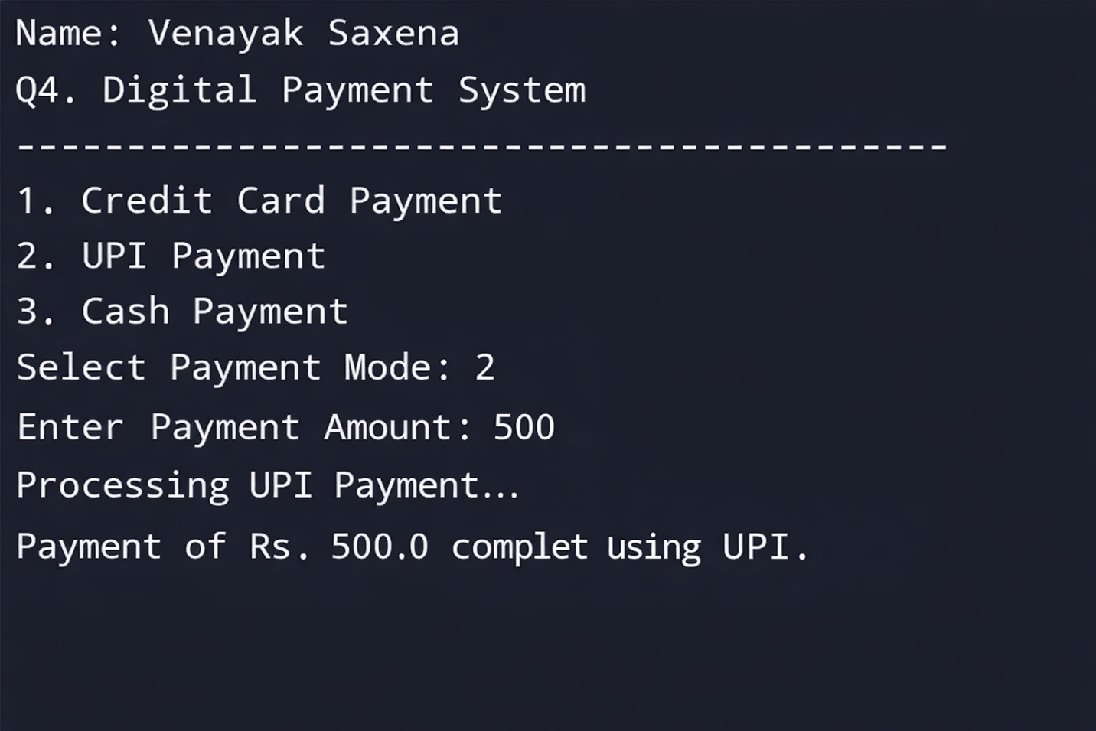

PROGRAM 5
Q5. Create a customised exception and also make use of all the 5 exception keywords.

import java.util.Scanner;
public class InvalidAgeException extends Exception {
InvalidAgeException(String message) {
super(message);
}
static void checkAge(int age) throws InvalidAgeException {
if (age < 18) {
throw new InvalidAgeException("Age must be 18 or above!");
} else {
System.out.println("Eligible to vote.");
}
}
public static void main(String[] args) {
System.out.println("Name: Venayak Saxena");
System.out.println("Q5. Custom Exception using 5 Exception Keywords");
System.out.println("-----------------------------------");
Scanner sc = new Scanner(System.in);
try {
System.out.print("Enter your age: ");
int age = sc.nextInt();
checkAge(age);
} catch (InvalidAgeException e) {
System.out.println("Exception Caught: " + e.getMessage());
} finally {
System.out.println("Program executed successfully.");
sc.close();
}
}
}
OUTPUT 5:

